T-Shirt Dresses

This another quick and easy dress that is suitable for some cultures where they require the girls to have sleeves. I often have people ask where I get the t-shirts... well I look out for coupons and shop the clearance racks. I also shop at charity shops and garage sales... but there is a word of warning. Please make sure that the t-shirts are "like new"... no visible signs of wear. Also, please do not use t-shirts that have writing (even Daddy's Little Girl may not be appropriate if a little girl has never known her dad)... No skulls, no patriotic symbols, no organizational symbols... just generic designs like flowers and butterflies or plain solid coloured t-shirts.

The first thing you have to decide is do you want the fabric attached in a high-waisted style, at the natural waist or at the hip. All three work well... sometimes the design dictates where the fabric should be attached.

Here is an example of a dress I made yesterday...

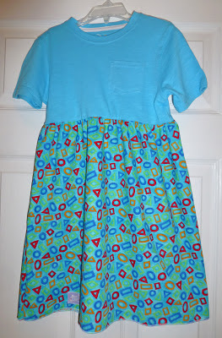

I like to choose bright colors as you can see.
The first step is to find the size of your t-shirt and then use this chart to determine the length of your dress

Size Cut Length
1/2 15"
1 17"
2 19"
3 21"
4 23"
5 25"
6 27"
7 29"
8 31"
10 33"
12 37"
14 42"

These sizes include 1/2" for hem and 1/2" for serging together... so the finished length is 1" shorter.

Lay your t-shirt over the edge of your cutting board. The chart is for our regular pillowcase dresses, so we are not measuring from the top of the t-shirt... we are measuring from the point that would be the same as the top of a pillowcase dress. I always put my hand on my chest and visualize where I would want the top of a dress to be and that is the point on the t-shirt we will measure from.

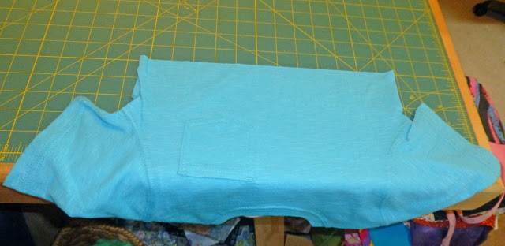

I decided to make a slightly high waisted dress. The measurement from the top middle chest to where I cut the t-shirt is 5" Now I subtract that 5" from the total length of a size 3 dress (which is 22") and I need to cut m fabric 18" long (this includes the extra 1"… see above) by the full width. I want my fabric to be about double the width of the circumference of the t-shirt so on larger dresses I might need to cut 1 1/2 lengths of fabric and sew a seam to get this double the width of the t-shirt. Depending long how long you cut your t-shirt… you will adjust the length of the shirt… not all dresses need to be high waisted…you can also make the dress at the natural waist or even a low-waisted dress.

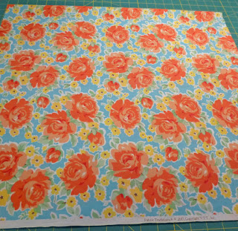

Sew the side seam and then finish the bottom of your fabric. Make sure that you finish your side seam... by either overlocking or by sewing a straight stitch and then a second row of zig zag stitching...
so that the seam does not fray.

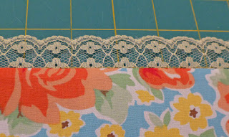

I chose to add lace to my hem. You can also do a traditional hem or a rolled hem.

Now you will need to make your side seam and remember to back stitch at each end to stop the seam coming apart. The press the seam and finish the edges by overlocking or zig-zag stitch.
If you are using the traditional method for gathering fabric pull your bobbin thread to the top

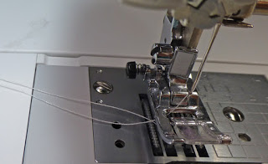

Set your machine onto it longest stitch. For my machine that is a 5
Stitch two rows about 1/4" apart

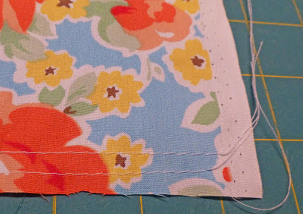

Now you need to pull your gathering stitches gently forming gathers

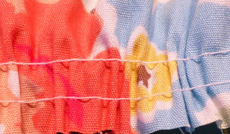

Gather your fabric the amount you need to fit onto your t-shirt
Using an overlocker or a zig zag stitch with right sides together attach your gathered skirt
to the bottom of the cut t-shirt

Now for the way I am doing my dresses...
My overlocker has a ruffling foot
Check you machine and if you have a ruffling foot it can save much time on the gathering part of this project. You will need to follow the instructions for your machine.

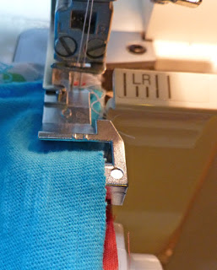

On my machine I ruffle or gather the fabric and attach it to the t-shirt in one step… just try to make sure that you stitch the side seam first then attach the skirt to the t-shirt.

The fabric is placed face up under the ruffling foot and the t-shirt is placed face down into the slot on the ruffling foot.
The serger/overlocker automatically gathers the bottom fabric while attaching it to the t-shirt. You have to be careful to ease your t-shirt gently so that you do not run out of fabric. Some rufflers just gather the fabric and then you attach to the t-shirt in a separate step.
This saves so much time when making a t-shirt dress

Finish off the seam edges with a zig-zag stitch to allow for stretch when the child pulls the dress over their head.

And you are done!!

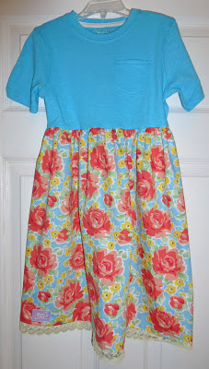

If you have any questions about the process please email me at
jayne-dressagirl@outlook.com
I found that this process is actually easier to do than it is to explain how to do.

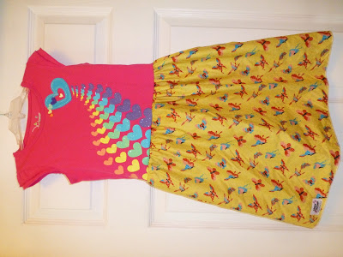

These dresses are very quick to make. I take the t-shirt and measure down from the point that would be at the same height as the top of a pillowcase dress (DO NOT measure from the neck... your dress will be too short). I decide where to cut off my t-shirt. For example: from that upper chest area to the bottom of t-shirt in number one (the horse dress) was 11 inches... I was making a size 4 so my fabric needed to be 13 inches long plus the hem. The t-shirt part of the dress can be different lengths... depending if you want an empire style dress or a low-waisted dress or also depending on where the design is on the t-shirt if there is one. I attach the two parts together using the ruffler foot on my serger/overlocker. If you do not have a serger/overlocker, you will need to gather the fabric and sew to the t-shirt using a zigzag stitch (if you use a straight stitch the fabric will unravel and you will not have the give you need when a child pulls the dress over their head).

